sCOOT: tHE iDEAL sCOOTER COMPANY

**Team Members:**

Kalyan Kumar Alisetty

Taylor Rebollar

Bruce Rehburg

Xitong Hu

# **Table of Contents**

Businesss 01

Market Analysis 02

MARKETING STRATEGY 10

cONCLUSION 12

**Business**

Scoot is a two-seat scooter sharing transportation company that is based of Austin, Texas. We provide electric scooters which are easy to drive for short distance of about 4-10 miles. This also tracks the location of available bikes using built-in GPS. Our company was started to help users based in densely populated areas such as downtown or university, to get to their destination quickly. Living in a densely populated area can create long drive times, walk times, or must use crowded public transit. This is not ideal when you need to get somewhere quickly. Scoot is prepared to solve that problem by providing high end electric two-seat scooters that the user(s) can operate from an app and drive wherever they need to go, and simply leave the bike at their destination. Even though the Austin, Texas market has competition that offer similar products, we believe that our product line of electric two-seat scooters will offer a more robust user experience for the working professional and academic students because of their availability and usability. This allows for a quicker ride time and our proprietary application software offers a seamless transition from renting to start the ride and paying at the end of your ride. Our Scooter is estimated to go between 20-25mph, and each charge will last approximately 60-70 miles. Both metrics are best in class and will immediately make Scoot competitive in the market. We believe that we can reduce travel time by eliminating long waits with public transit and eliminate high cost associated with Uber and Lyft. Our upfront cost to rent the bike is on average 50 cents lower than the competition(similar scooters) and 5 cents lower per minute of use. Scooters will be charged overnight and re-placed in certain locations based on city demand using location analytics.

Our app design is made with our user experience in mind. The seamless NFC micro transaction to unlock the bike is done by just hovering your phone over the handlebar (NFC payment must be set up on users’ phone) and once the destination is reached, simply just hit “destination reached” in the app. A receipt with the miles and time is sent straight to your phone. Scoot is working to provide a high-end user experience by providing an environmentally clean and accessible mode of transportation to everyone in the Austin, Texas area.

Austin, Texas is home to four separate scooter sharing companies. These four companies have a total of 11,000 scooters in the Austin market currently. We believe the market is saturated with scooters, which primarily are ridden on sidewalks due to their small size and limited speed and therefore do not have the capacity for commuting travel. Scoot has positioned itself as an upscale yet economical and efficient way for users to accomplish multiple tasks, such as getting groceries (our bikes are equipped with a large basket) and commuting to work or school. In 2018, P&S Intelligence valued the scooter sharing industry at 99.8 million dollars and sees the industry growing 24.4% over the next five years to 553 million dollars. Based on our own analysis we expect this growth to be attributed to consumer demand of more commuter friendly electric powered scooters that can get you anywhere you wish to go in the town.

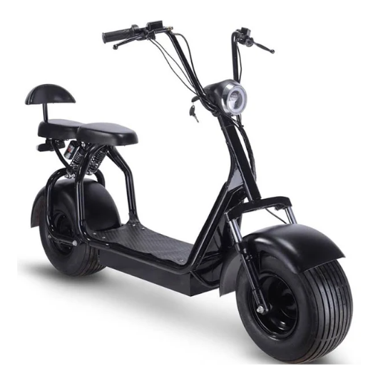The main features of our scooter are

* Top speed: 20mph
* Best for 10-25 minutes’ ride
* One or two adults
* Provided with bicycling basket

**Analysis**

The bike sharing mobile application have gained popularity in recent times due to many advantages. It is easy to pick up and drop off at any nearby destinations which saves us a lot of parking fees at offices, restaurants, recreation centers, and universities. As the growth of population and traffic is more for Austin, we have chosen it as our prime location to start our new business. The below diagram explains the demographic features of the Austin City, TX

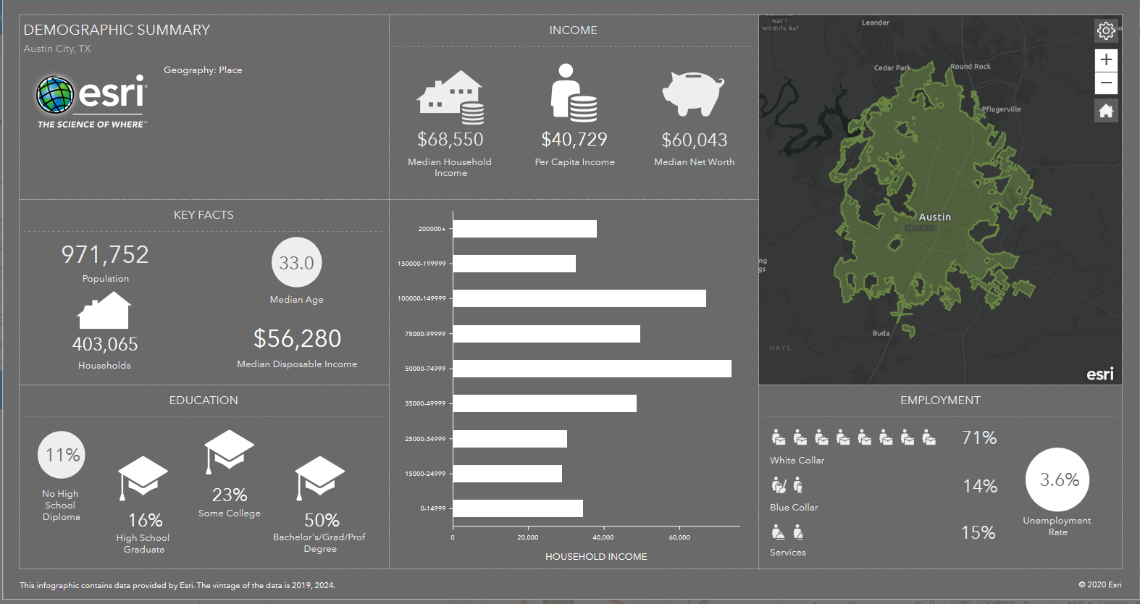

The different factors influencing our scooter business are explained in detail below.

1. 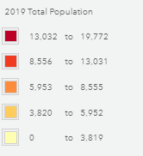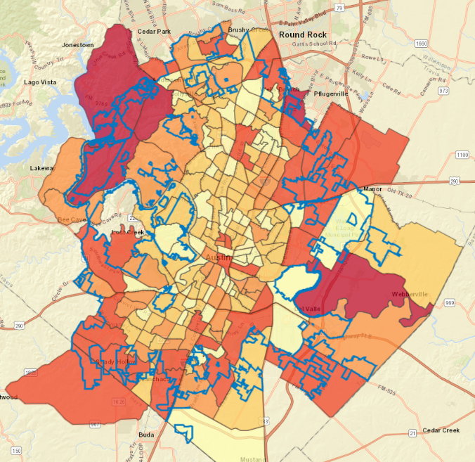**Population**

As the population of the area is an important feature for any business to succeed. The beside picture shows the population spread in the city of Austin. The population density is more near to the boundaries of the city and decreases as we move more south and northeast. The lowest population density is at the center of the city with range of about 0 to 3,000 people

1. 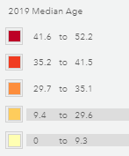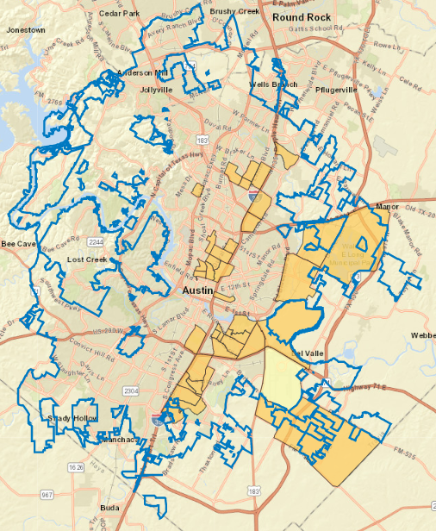**Median Age**

The people using the scooter should be of the lower age ranging from 12 to 30 years, as its not marketable for the older adults. Adults have a risk of losing balance while driving and do not have any interest in using them. The beside screenshot presents you the people who are below 30 years of age.

1. 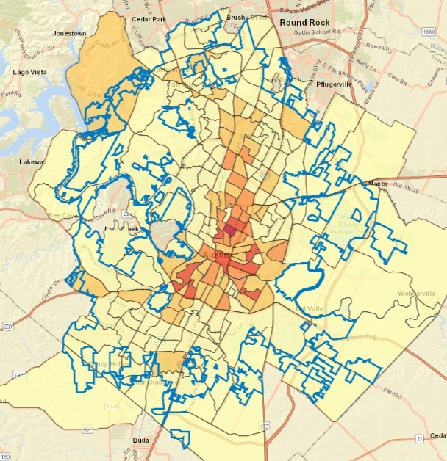**Bicycle users**

The people who are already moving on the bicycles can be benefited by these scooters because of their low cost and availability . Most of the bicycle users are around the center of the city as shown to the right.

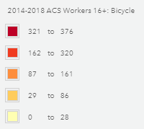

1. 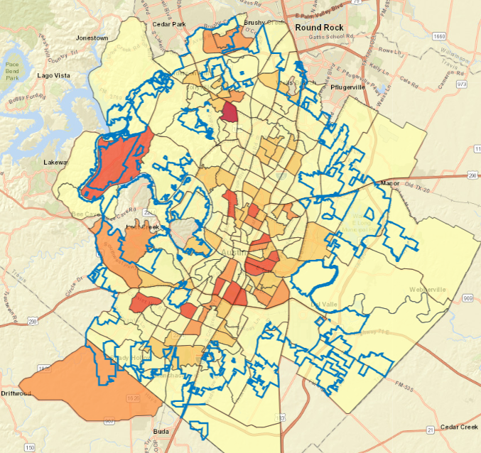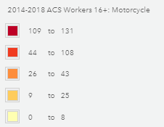**Motorcycle users**

As this type of users are already using a scooter type of vehicle, our scooter will help to easily move on the foot paths to avoid traffic and their availability in every possible location. Most of these users are around the center of the city as shown to the right.

1. 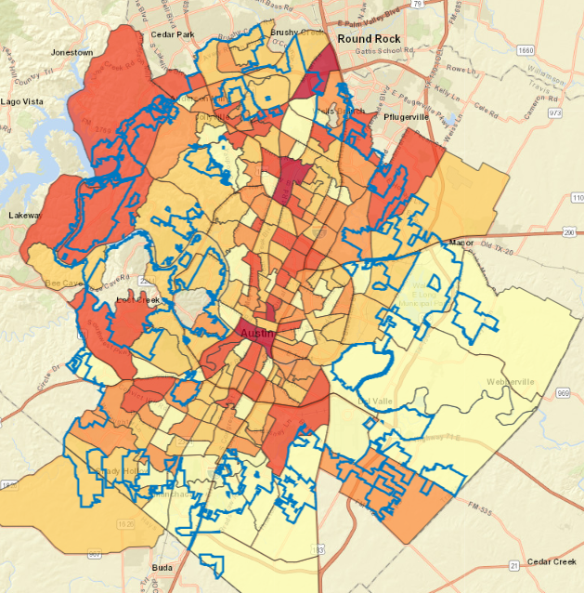**People with 5-10 minutes commute**

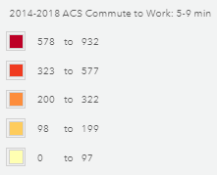As our scooters are most useful for users who are having their offices very nearby but wanted to traffic by not using their cars or public transport. The distribution of those users is shown in the picture to the right.

1. 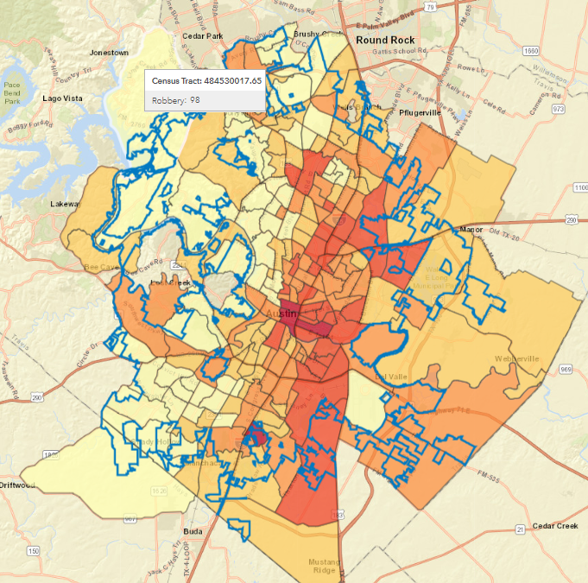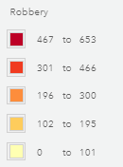**Robberies**

We have strategically placed our scooters overnight in areas that have low robbery index scores. The figure to the right shows the west side of the city has low robbery index scores. Our users can feel comfortable knowing that we take their safety as a top priority.

1. 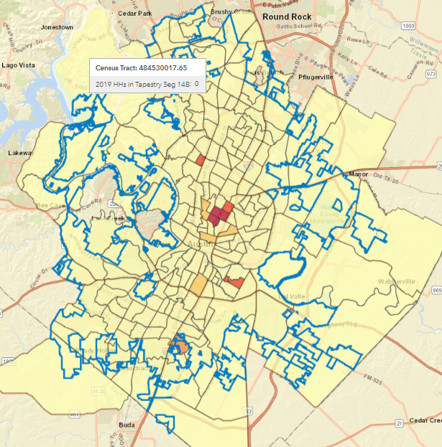**Youth**

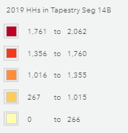Students are one of our main focal points when marketing our scooters. Because of this, we have focused on areas where the student community is densely populated. The plots to the right give a great visual of the areas which are densely populated by young students.

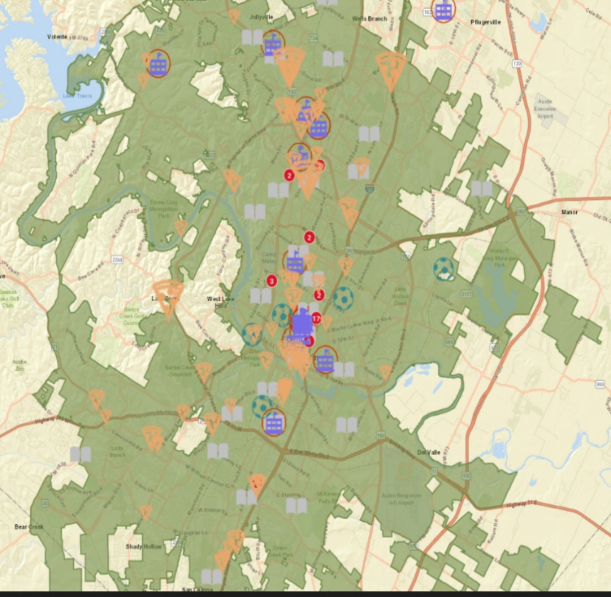Most of the students visit the restaurants, libraries, university, recreation centers which are near to their homes. The figure to the right shows different popular restaurants, universities, libraries, and recreation centers that students can visit using our scooter

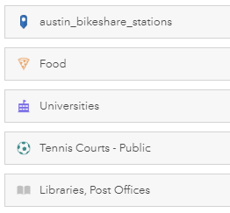

As the demand for the scooter vary throughout the day and type of the day(weekend or weekday), we have analyzed behaviors based on this demand by collecting data from the city of Austin’s public transportation data website.

The data consists of every trip detail of the present user. For example, time of the trip, trip start census tract, trip end census tract, type of the scooter used and so on. From that we have summarized the data to find the average number of trips taken by the users during each hour of the day and average number of trips taken during weekday and weekend.

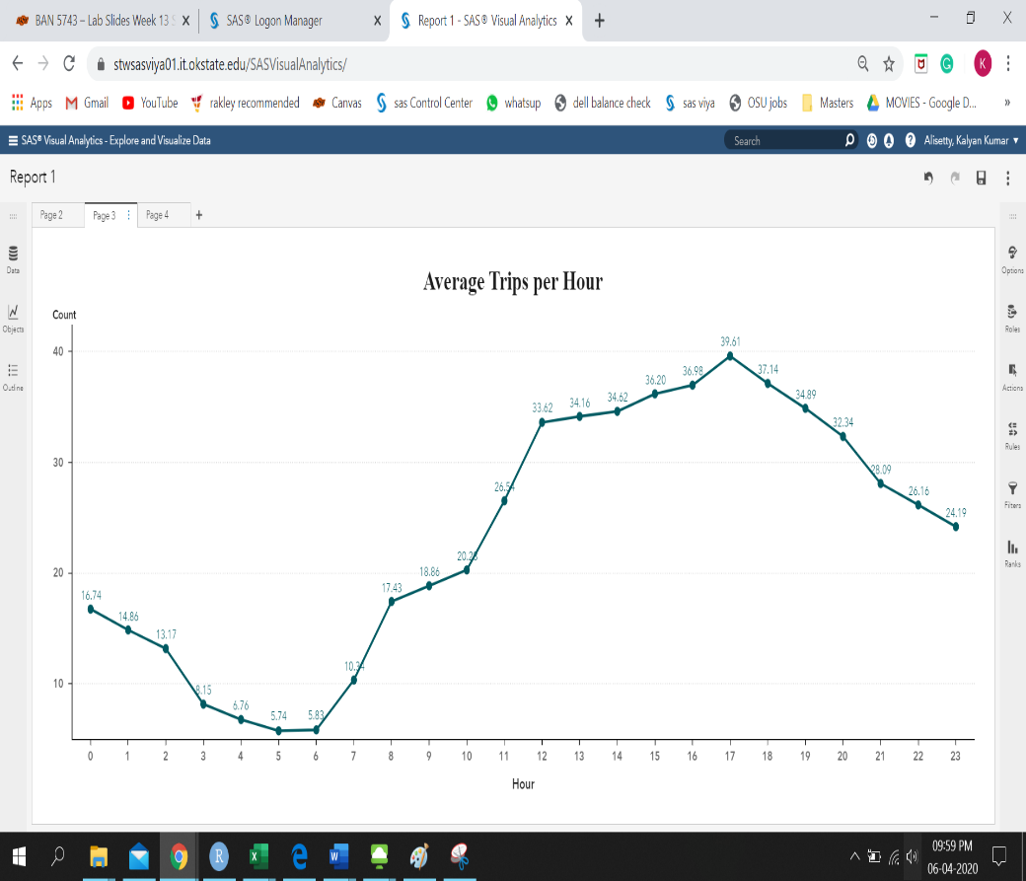The beside graph shows the average number of trips taken by the people of Austin in each hour. The average number of trips is high during the evening as most of the people return home from office using scooters and also as the vehicle traffic is more during the evening.

The beside graph shows the average number of trips taken by the user on each day of a week. The weekend on the x-axis signifies Sat and Sun. The graph indicates an increase in the number of the trips in the weekdays as most of the people would go to the offices, universities and restaurants for the lunch and dinner.

After analysis the data, we have found the areas from where most of the people tend to pick up these scooters based on the time and type of the day. Later, by overlapping it with most profited areas with the beside criteria for our business we have identified the locations which are most suitable to place our scooters at a time of a day.

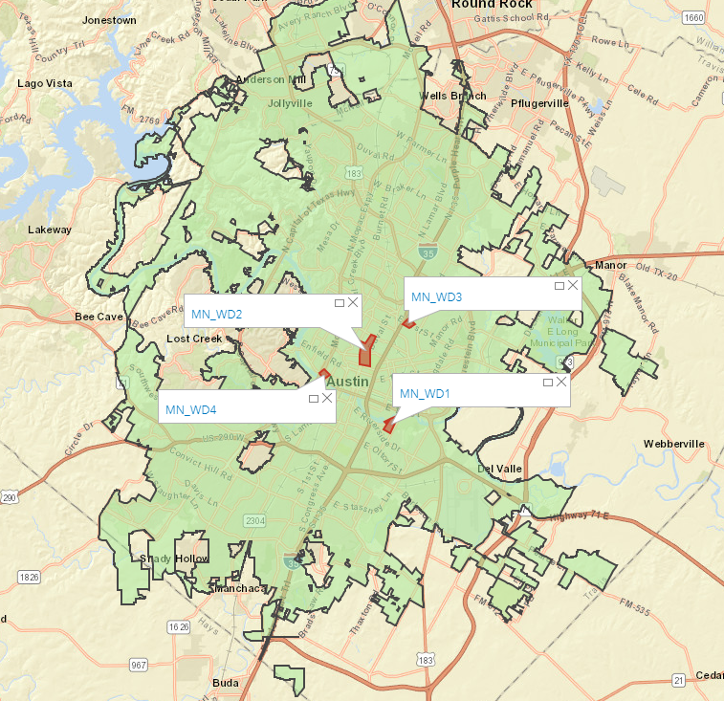**Weekday Morning:**

Out of the all the four locations, we have performed suitability analysis to find the location which earns us most profit and found it to be Location 2 (MN_WD2)

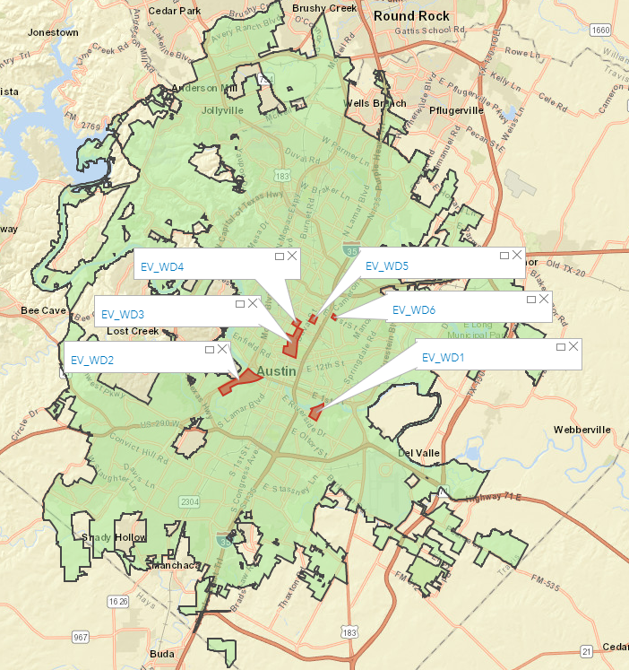

**Weekday Evening:**

We have identified six different location where we can place our scooters during evenings of a weekday which are nearby offices and refreshments centers. Out of the 6 locations its expected that location 3 (EV_WD3) earns us the most profit as it’s near to the University of Austin.

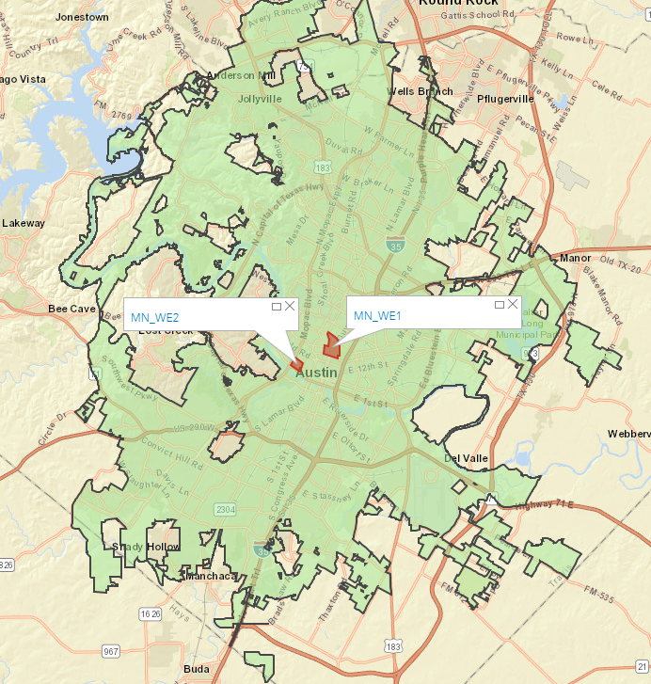**Weekend Mornings:**

As people begin their day a bit late on weekends, we could find only 2 possible locations where they could possibly begin their ride. Location 1 is expected to earn more profit compared to the two locations as it near to many restaurants and libraries.

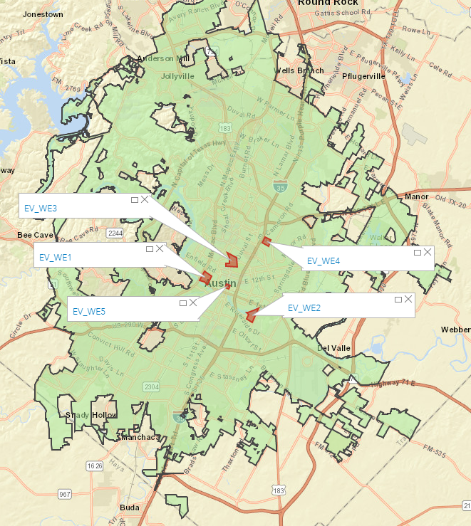**Weekend Evening:**

As the users generally tend to go to parties in the weekend evenings, we could possibly identify more locations where the users are most likely to begin their ride. Out of the 5 locations, the location 3 is expected to earn more as it’s in the center of the city.

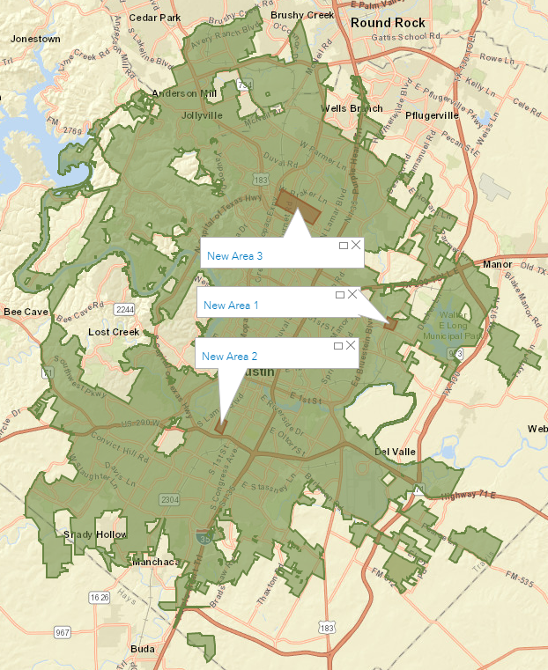**New Trail Stations:**

As most the profitable locations are almost in the center of the cities, we have identified few more locations which has similar demographics and huge demand for this type of business. The below are the three locations in which area 3 is expected to generate more revenue.

**Marketing Strategy**

**Current Target Customer Group:**

We have analyzed the demographics of the common area which are suitable for any time of the day using tapestry segment analysis and segmented our potential customers for our current target locations. Surrounding communities are mainly university students from college towns segment (35%) and dorms to diplomas (65%) segment. So, we have designed our marketing strategy according to their market profile.

**Customer Habits:**

The dorms to diplomas are the students with age less than 25 years old and earn low income (below $15,000). From the tapestry profile we have found that they generally enjoy going to movies, bars, and participate in sports. Their life is mainly about study, part-time for school and socialize during free time. They use mobile phone for all aspects of life including shopping, schoolwork, news, social media, and entertainment. They care about fashion and are also impulse buyer, who like try different brands.

We have integrated our scooter service with current popular social apps such as Facebook, WhatsApp, etc. to enhance our product as part of their social life. When the users communicate with their friends about hanging out to some restaurants or bars, our scooter information will pop up and give them the nearest scooter location, the estimate time, and surrounding locations. Users can share their scooter location using the mobile application with their friends. Since they are impulse buyer and would like to try different things, the coupons or promotions associated with our service will be an additional benefit for the users. We provide them with cinema discounts, shopping discounts, and surrounding restaurant/beverage coupons to them to help get them enjoy their student life.

**Student Club:**

As most the central region of Austin is engaged with the current students of the universities, we have focused our strategy around them in order to lure them to use our vehicles for restaurants, classrooms, dorms, grocery stores and recreation centers.

* Coupons or discounts for student related stuff. They get some stationary, electronics, sports, clothes, and theater coupons after being a member of our business.
* Availability of nearby stores will be sent to users when they open our application to find a vehicle for their ride.
* Provide free ride to home at sponsored stores by scanning their billing receipt.
* Referral program. They will get $10 ride credits for each referral.
* Provide some shop recommendations based on their travel history and time of the day.
* We provide 1% of their amount back to their wallet as cashback and 1% to the charity which includes social responsibility.

**Citizen and Tourist Club:**

Our next focus is on the common people who need a ride in downtown area. These users can ride using our vehicles to nearby places in city area. So, we offer the below benefits for them. Our scooters will be added at the entrance or some areas of the parks or sights soon, which can be used by the travelers to move inside the parks and tourist sights.

* Surrounding shop store, beverage store or restaurant coupons
* 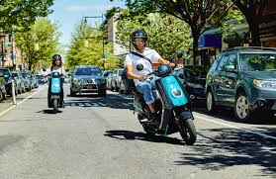Monthly membership for users who travel to their office.
* Provide tour guide or scenic route direction
* Provide discounts for some city museum, parks, or sights.
* Family bundle, purchase family ride to unlock 2 vehicles at one time.

**Conclusion**

Micro mobility is an established market where the demand continues to grow. Although there are multiple competitors, Scoot prides itself offering superior products. Our main goal is to both retain old customers and obtain new ones. For the first year we will focus on our primary customer demographic of college students and young professionals. Our day-to-day operations will consist of dropping off the scooters at the locations popular in the morning and relocating daily. We will use our app to map the popular paths and locations to help us place the scooters more efficiently as we grow. We will only produce parts and replacement scooters instead of focusing on increasing the production of new scooters. This will be the maintaining phase of our business while we increase in popularity.

In our three-year plan we will ramp up our production to match the increasing demand which will involve adding another manufacturing facility. We will also infiltrate the three locations identified to be profitable (see above map) based on our criteria as well as identify new areas of growth. Considering it as a growing market, it is imperative that we keep up with the competition and come up with innovative ideas regularly. We will add a development and marketing team to come up with new ideas to better our product and might consider the possibility of manufacturing additional types of products. Our app will undergo a new release and match compatibility with new technology that the future holds. We will expand into Dallas, Oklahoma City and Tulsa areas. The sky is the limit.

**References:**

1. <https://micro.mobility.austin.gov/>
2. [https://www.kaggle.com/jboysen/austin-bike/data#](https://www.kaggle.com/jboysen/austin-bike/data)
3. <https://data.austintexas.gov/Transportation-and-Mobility/Shared-Micromobility-Vehicle-Trips/7d8e-dm7r>